MAD LAB CYCLE 2

1.Create 2 Activities from 1st Activity on click move to 2nd activity (Using Intent)

activity-main.XML
<?xml version="1.0" encoding="utf-8"?>
<LinearLayout
android:id="@+id/p1"
android:layout_width="match_parent"
android:layout_height="match_parent"
android:orientation="vertical"
android:gravity="center"
xmlns:android="http://schemas.android.com/apk/res/android">
<Button
android:layout_width="wrap_content"
android:layout_height="wrap_content"
android:gravity="center"
android:onClick="click"
android:text="Click"/>
</LinearLayout>
MainActivity.java
package com.example.sjcet.twoactivity;
import android.support.v7.app.AppCompatActivity;
import android.os.Bundle;
import android.view.View;
import android.content.Intent;
import android.widget.Button;
public class MainActivity extends AppCompatActivity {
@Override
protected void onCreate(Bundle savedInstanceState) {
super.onCreate(savedInstanceState);
setContentView(R.layout.activity_main);
}
public void click(View view) {
Opennewactivity();
}
public void Opennewactivity()
{
Intent intent=new Intent(this,Main2Activity.class);
startActivity(intent);
}
}
activity-main2.xml
<?xml version="1.0" encoding="utf-8"?>
<android.support.constraint.ConstraintLayout
xmlns:android="http://schemas.android.com/apk/res/android"
xmlns:app="http://schemas.android.com/apk/res-auto"
xmlns:tools="http://schemas.android.com/tools"
android:layout_width="match_parent"
android:layout_height="match_parent"
android:layout_gravity="center"
tools:context=".Main2Activity">
<TextView
android:layout_width="wrap_content"
android:layout_height="wrap_content"
android:gravity="center"
android:text="Activity 2"
tools:layout_editor_absoluteX="164dp"
tools:layout_editor_absoluteY="237dp" />
</android.support.constraint.ConstraintLayout>
Main2Activity.java
package com.example.sjcet.twoactivity;
import android.support.v7.app.AppCompatActivity;
import android.os.Bundle;
public class Main2Activity extends AppCompatActivity {
@Override
protected void onCreate(Bundle savedInstanceState) {
super.onCreate(savedInstanceState);
setContentView(R.layout.activity_main2);
}
}
OUTPUT
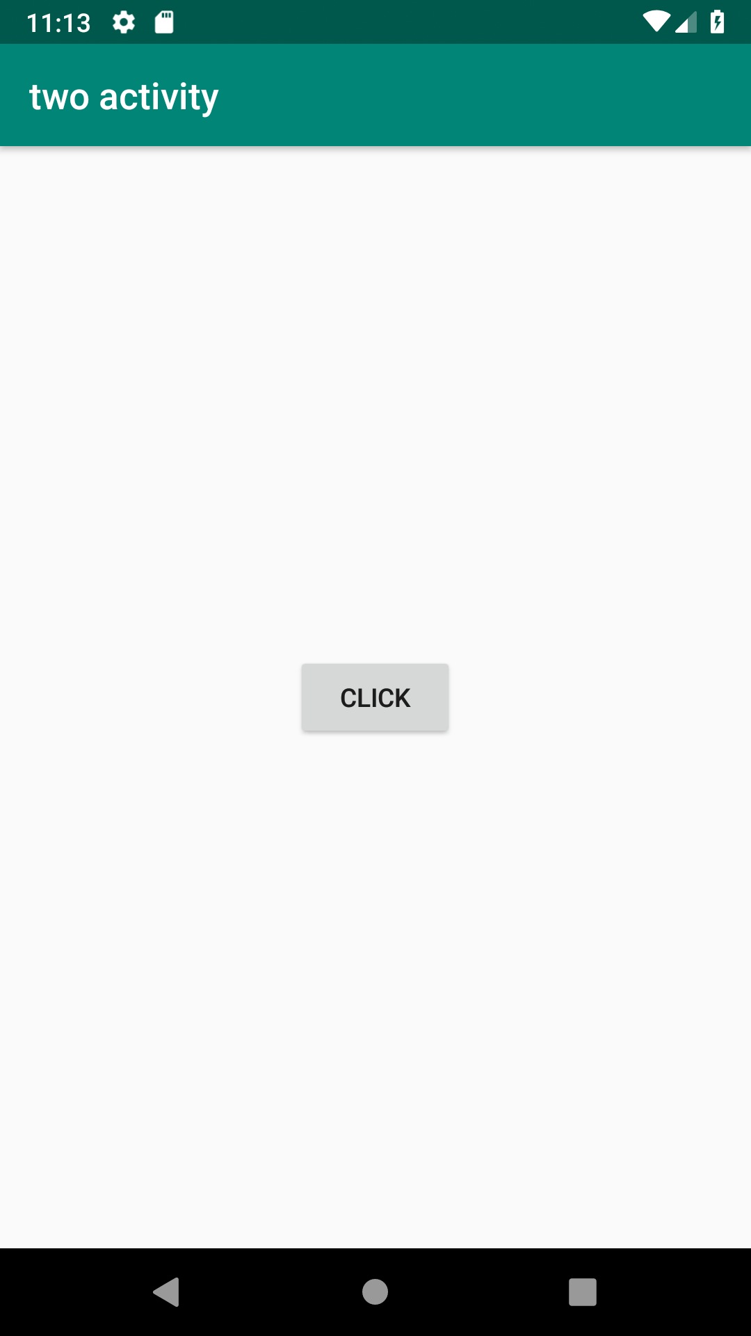

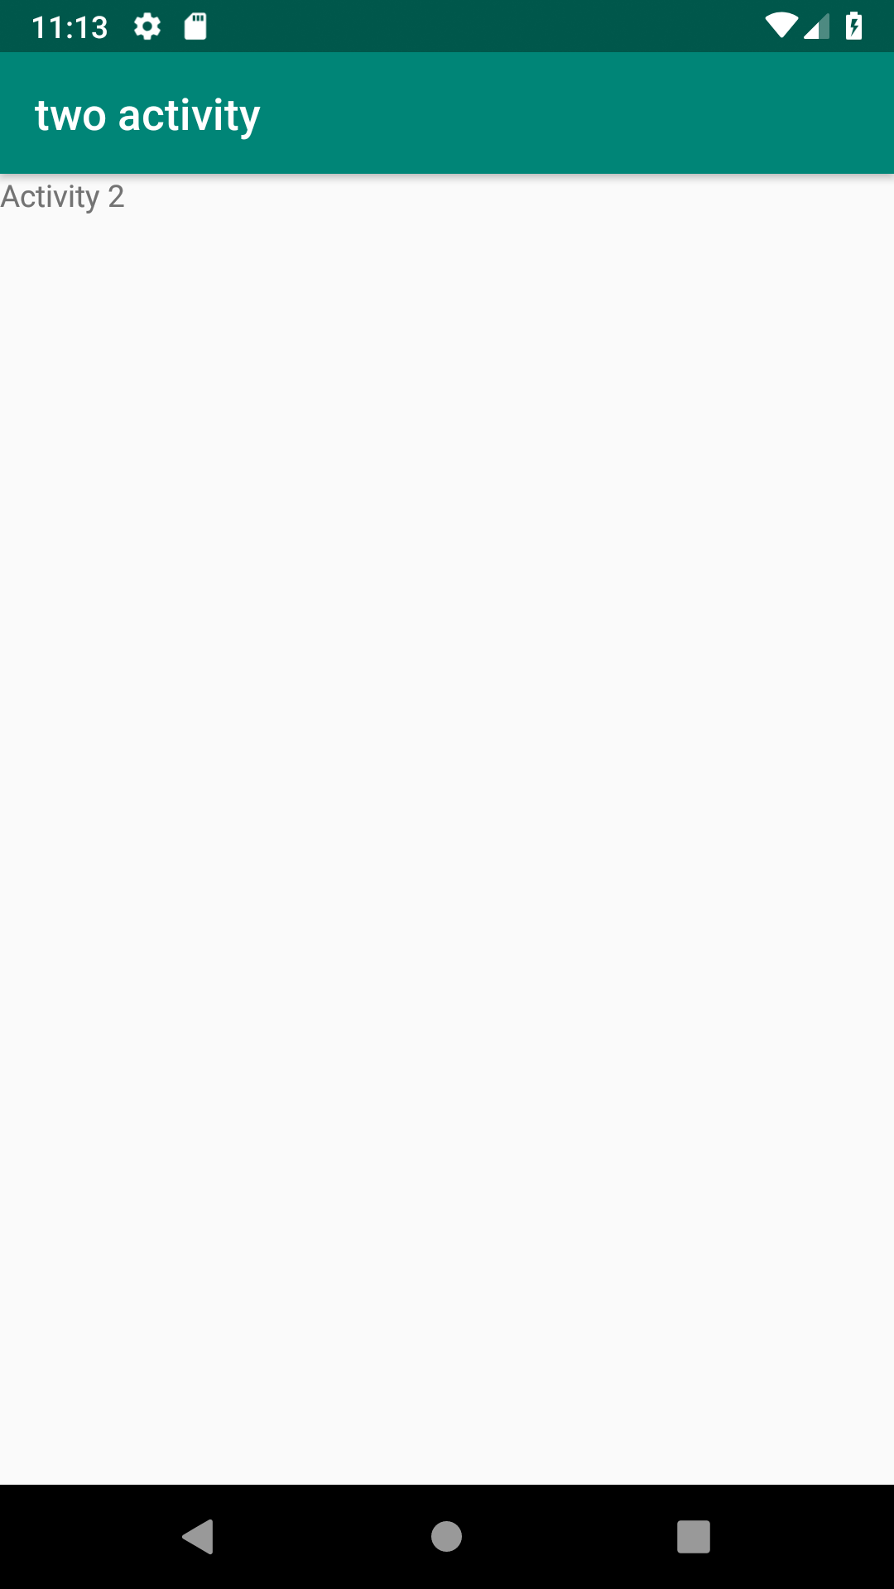

2.Create an Activity and move to facebook login page on a button click(making use of Intent).

